**Document Status: Approved**

**Approved by: Management Representative**

**Released by : Mentor Labs**

**Revision / Document History**

|  |  |  |  |
| --- | --- | --- | --- |
| **Ver.** | **Date** | **Changed by** | **Modifications** |
|  |  |  |  |
| 01 | 12/03/2024 | Bhagyashree | Initial version |
|  |  |  |  |
|  |  |  |  |

**List of Abbreviations**

DFD **D**ata **F**low **D**iagram

E-R **E**ntity **R**elationship

RS **R**equirement **S**pecification

RTO **R**egional **T**ransport **O**ffice

TMS **T**raffic **M**anagement **S**ystem

**Table of Contents**

**1.** **Introduction 3**

**1.1** **Purpose 3**

**1.2** **Scope 3**

**1.3** **Definitions, Acronyms and Abbreviations 3**

**1.4** **References 3**

**1.5** **Coordinators 3**

**2.** **Software Requirements 3**

**2.1** **Operational Requirements 3**

**2.2** **Functional Requirements 4**

**2.3** **User Interface Requirements 7**

**2.4** **External Interface Requirements 18**

**3.** **Project Execution Related Requirements 18**

**3.1** **Development Environment 18**

Technologies to be used for development of the Application: **18**

**3.2** **Design requirements 18**

**3.3** **Coding requirements 18**

**3.4** **Error handling requirements 18**

**3.5** **Resource Requirements 18**

Technologies to be used for development of the Application: **18**

**3.6** **Risk management 18**

**3.7** **Training Requirements 18**

**4.** **Testing Requirements 18**

**5.** **Quality Assurance Activities 19**

**6.** **Software Acceptance Criteria 19**

**7.** **Deliverables 19**

**7.1** **List of Deliverables 19**

**7.2** **Delivery 19**

**8.** **Requirements Acceptance Statement 19**

# Introduction

## Purpose:

#### *This main purpose of Traffic Management System is to ease the work of cop who can raise and clear an offense against a vehicle as well as RTO who can register a vehicle, transfer a vehicle, manage vehicle, owner, and registration details.*

## Scope:

## *The scope of this application is limited to offense details. Making the payment and scraping the vehicle is not included under this scope.*

## Definitions, Acronyms and Abbreviations

*RTO* ***R****egional* ***T****ransport* ***O****ffice*

## References

*Not Applicable*

## Coordinators

1. *Bhagyashree*

# Software Requirements

## Operational Requirements *The TMS system is used to :*

* *Raising an offence against a vehicle.*
* *Clearing the offence.*
* *Viewing the offence committed by vehicle.*
* *Registering a vehicle.*
* *Transfer of a vehicle.*
* *Report generation.*

## Functional Requirements

***FIGURE 2.1 USE CASE DIAGRAM FOR TMS***

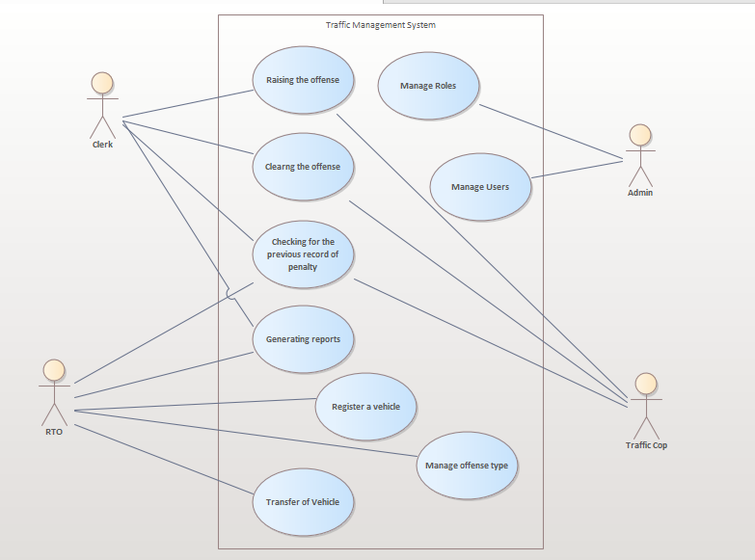

|  |  |  |
| --- | --- | --- |
| Requirement Tag ID | *RS-1-1-1* | |
| *Source/Trigger* | *Traffic cop* | |
| *Description* | *Input* | *Vehicle registration number* |
| *Process* | *Check the offense history for the input* |
| *Output* | *If any offense found, show the details of both paid and unpaid offences*  *Otherwise, display “No record of offense found.”* |
| *Validation Method* |  | |

|  |  |  |
| --- | --- | --- |
| Requirement Tag ID | *RS-1-1-2* | |
| *Source/Trigger* | *Traffic cop* | |
| *Description* | *Input* | *Vehicle registration nuber, Offence dtae and time, place, proof, offence type, user id* |
| *Process* | *Raising the offense -*  *Collect all the details and then raise an offence against that vehicle.* |
| *Output* | *If successful then display, Offence raised against that registration no. else display offence not raised.* |
| *Validation Method* |  | |

|  |  |  |
| --- | --- | --- |
| Requirement Tag ID | *RS-1-1-3* | |
| *Source/Trigger* | *Traffic cop* | |
| *Description* | *Input* | *Vehicle registration number* |
| *Process* | *Clearing the offense penalty -  Check for the offence committed which are unpaid. Select the offence which you want to clear and then change the penalty status to paid.* |
| *Output* | *Offence cleared.* |
| *Validation Method* |  | |

|  |  |  |
| --- | --- | --- |
| Requirement Tag ID | *RS-1-2-1* | |
| *Source/Trigger* | *Admin* | |
| *Description* | *Input* | *role_name* |
| *Process* | *Fetch the details related to given input.* |
| *Output* | *Display the details.* |
| *Validation Method* |  | |

|  |  |  |
| --- | --- | --- |
| Requirement Tag ID | *RS-1-2-2* | |
| *Source/Trigger* | *Admin* | |
| *Description* | *Input* | *role_name* |
| *Process* | *Collect the input and add new role.* |
| *Output* | *Display New role added/ not added.* |
| *Validation Method* |  | |

|  |  |  |
| --- | --- | --- |
| Requirement Tag ID | *RS-1-2-3* | |
| *Source/Trigger* | *Admin* | |
| *Description* | *Input* | *role_name, new role name* |
| *Process* | *Get the details of entered role name and then update role name to given new role name.* |
| *Output* | *Display “role updated / deleted”.* |
| *Validation Method* |  | |

|  |  |  |
| --- | --- | --- |
| Requirement Tag ID | *RS-1-2-4* | |
| *Source/Trigger* | *Admin* | |
| *Description* | *Input* | *role_name* |
| *Process* | *Fetch the details related to given input and delete.* |
| *Output* | *Display “Role delete / not deleted”* |
| *Validation Method* |  | |

|  |  |  |
| --- | --- | --- |
| Requirement Tag ID | *RS-1-2-5* | |
| *Source/Trigger* | *Admin* | |
| *Description* | *Input* | *User id* |
| *Process* | *Fetch the details related to given input.* |
| *Output* | *Display the details.* |
| *Validation Method* |  | |

|  |  |  |
| --- | --- | --- |
| Requirement Tag ID | *RS-1-2-6* | |
| *Source/Trigger* | *Admin* | |
| *Description* | *Input* | *User name, password, email id, phone number, role* |
| *Process* | *Collect the input and add new user.* |
| *Output* | *Display New user added/ not added and the detaild off added user.* |
| *Validation Method* |  | |

|  |  |  |
| --- | --- | --- |
| Requirement Tag ID | *RS-1-2-7* | |
| *Source/Trigger* | *Admin* | |
| *Description* | *Input* | *User id, new password* |
| *Process* | *Get the details of entered user id and then update password to given new password.* |
| *Output* | *Display “User updated / deleted”.* |
| *Validation Method* |  | |

|  |  |  |
| --- | --- | --- |
| Requirement Tag ID | *RS-1-2-8* | |
| *Source/Trigger* | *Admin* | |
| *Description* | *Input* | *User id* |
| *Process* | *Fetch the details related to given input and delete.* |
| *Output* | *Display “User delete / not deleted”* |
| *Validation Method* |  | |

|  |  |  |
| --- | --- | --- |
| Requirement Tag ID | *RS-1-3-1* | |
| *Source/Trigger* | *RTO* | |
| *Description* | *Input* | *Vehicle registration number* |
| *Process* | *Clearing the offense penalty -  Check for the offence committed which are unpaid. Select the offence which you want to clear and then change the penalty status to paid.* |
| *Output* | *Penalty cleared.* |
| *Validation Method* |  | |

|  |  |  |
| --- | --- | --- |
| Requirement Tag ID | *RS-1-3-2* | |
| *Source/Trigger* | *RTO* | |
| *Description* | *Input* | *Owner id* |
| *Process* | *Fetch the owner details for the given owner id.* |
| *Output* | *Display all the details of owner like owner name, mobile number, address, pin code, occupation.* |
| *Validation Method* |  | |

|  |  |  |
| --- | --- | --- |
| Requirement Tag ID | *RS-1-3-3* | |
| *Source/Trigger* | *RTO* | |
| *Description* | *Input* | *Owner id, id type, first name, last name, gender, date of birth, phone number, address, pincode, occupation* |
| *Process* | *Check for the presence of owner in the database, if not found add the new details given as input.* |
| *Output* | *Display Owner already exists or owner details added.* |
| *Validation Method* |  | |

|  |  |  |
| --- | --- | --- |
| Requirement Tag ID | *RS-1-3-4* | |
| *Source/Trigger* | *RTO* | |
| *Description* | *Input* | *Owner id, address* |
| *Process* | *Search for details of given owner id, and then update the details with given new details.* |
| *Output* | *Display owner details updated.* |
| *Validation Method* |  | |

|  |  |  |
| --- | --- | --- |
| Requirement Tag ID | *RS-1-3-5* | |
| *Source/Trigger* | *RTO* | |
| *Description* | *Input* | *Owner id* |
| *Process* | *Fetch the details of given owner id and display them and delete it* |
| *Output* | *Display owner details deleted.* |
| *Validation Method* |  | |

|  |  |  |
| --- | --- | --- |
| Requirement Tag ID | *RS-1-3-6* | |
| *Source/Trigger* | *RTO* | |
| *Description* | *Input* | *Engine number, chassis number, vehicle type, brand, color, fuel used, manufacture date, manufacturer name, model number.* |
| *Process* | *Collect all the details and add them into the database.* |
| *Output* | *Display Vehicle details added / vehicle already exists.* |
| *Validation Method* |  | |

|  |  |  |
| --- | --- | --- |
| Requirement Tag ID | *RS-1-3-7* | |
| *Source/Trigger* | *RTO* | |
| *Description* | *Input* | *Vehicle id* |
| *Process* | *Fetch the details of given vehicle id.* |
| *Output* | *Display the details of given vehicle id.* |
| *Validation Method* |  | |

|  |  |  |
| --- | --- | --- |
| Requirement Tag ID | *RS-1-3-8* | |
| *Source/Trigger* | *RTO* | |
| *Description* | *Input* | *Vehicle id, color* |
| *Process* | *Fetch the details of given vehicle id and update the color to new color.* |
| *Output* | *Display vehicle details updated.* |
| *Validation Method* |  | |

|  |  |  |
| --- | --- | --- |
| Requirement Tag ID | *RS-1-3-9* | |
| *Source/Trigger* | *RTO* | |
| *Description* | *Input* | *Vehicle id* |
| *Process* | *Fetch the details of given vehicle id and display the details and then delete.* |
| *Output* | *Display vehicle details deleted.* |
| *Validation Method* |  | |

|  |  |  |
| --- | --- | --- |
| Requirement Tag ID | *RS-1-3-10* | |
| *Source/Trigger* | *RTO* | |
| *Description* | *Input* | *Offence name, vehicle type, penalty amount* |
| *Process* | *Get all the details of offence type given in the input and then add.* |
| *Output* | *Display new offence type created.* |
| *Validation Method* |  | |

|  |  |  |
| --- | --- | --- |
| Requirement Tag ID | *RS-1-3-11* | |
| *Source/Trigger* | *RTO* | |
| *Description* | *Input* | *Offence id* |
| *Process* | *Fetch the details related to given offence id.* |
| *Output* | *Display offence type details.* |
| *Validation Method* |  | |

|  |  |  |
| --- | --- | --- |
| Requirement Tag ID | *RS-1-3-12* | |
| *Source/Trigger* | *RTO* | |
| *Description* | *Input* | *Offence id, penalty amount* |
| *Process* | *Fetch the details related to given offence id and then update the penalty amount with given input.* |
| *Output* | *Display offence type details updated.* |
| *Validation Method* |  | |

|  |  |  |
| --- | --- | --- |
| Requirement Tag ID | *RS-1-3-13* | |
| *Source/Trigger* | *RTO* | |
| *Description* | *Input* | *Offence id* |
| *Process* | *Fetch the details related to given offence id and delete it.* |
| *Output* | *Display offence type details deleted.* |
| *Validation Method* |  | |

|  |  |  |
| --- | --- | --- |
| Requirement Tag ID | *RS-1-3-14* | |
| *Source/Trigger* | *RTO* | |
| *Description* | *Input* | *Registration number, vehicle id, owner id, registration date* |
| *Process* | *Check whether the given registration number is there or not, if not found add the new details.* |
| *Output* | *Display Vehicle registered.* |
| *Validation Method* |  | |

|  |  |  |
| --- | --- | --- |
| Requirement Tag ID | *RS-1-3-15* | |
| *Source/Trigger* | *RTO* | |
| *Description* | *Input* | *Registration number, new owner details* |
| *Process* | *Fetch the vehicle and owner details of given registration number and if no offences found then transfer the vehicle by updating old owner details with new owner details.* |
| *Output* | *Display Vehicle Transferred/ not transferred.* |
| *Validation Method* |  | |

|  |  |  |
| --- | --- | --- |
| Requirement Tag ID | *RS-1-3-16* | |
| *Source/Trigger* | *RTO* | |
| *Description* | *Input* | *Registration number* |
| *Process* | *Get the details of vehicle and owner related to given registration number and store it in a file.* |
| *Output* | *Report generation successful / unsuccessful.* |
| *Validation Method* |  | |

|  |  |  |
| --- | --- | --- |
| Requirement Tag ID | *RS-1-4-1* | |
| *Source/Trigger* | *Clerk* | |
| *Description* | *Input* | *Vehicle registration number* |
| *Process* | *Check the offense history for the input* |
| *Output* | *If any offense found, show the details of both paid and unpaid offences.*  *Otherwise, display “No record of offense found.”* |
| *Validation Method* |  | |

|  |  |  |
| --- | --- | --- |
| Requirement Tag ID | *RS-1-4-2* | |
| *Source/Trigger* | *Clerk* | |
| *Description* | *Input* | *Vehicle registration number, Offence date and time, place, proof, offence type, user id* |
| *Process* | *Raising the offense -*  *Collect all the details and then raise an offence against that vehicle.* |
| *Output* | *If the history is updated then display -If successful then display, Offence raised against that registration no. else display offence not raised.* |
| *Validation Method* |  | |

|  |  |  |
| --- | --- | --- |
| Requirement Tag ID | *RS-1-4-3* | |
| *Source/Trigger* | *Clerk* | |
| *Description* | *Input* | *Vehicle registration number* |
| *Process* | *Clearing the offense penalty -  Check for the offence committed which are unpaid. Select the offence which you want to clear and then change the penalty status to paid.* |
| *Output* | *Offence cleared.* |
| *Validation Method* |  | |

|  |  |  |
| --- | --- | --- |
| Requirement Tag ID | *RS-1-4-4* | |
| *Source/Trigger* | *Clerk* | |
| *Description* | *Input* | *Vehicle registration number* |
| *Process* | *Report based on vehicle no.-*  *Get all the offence details and the owner details of the given input into a file.* |
| *Output* | *Report generation successful/ failed.* |
| *Validation Method* |  | |

|  |  |  |
| --- | --- | --- |
| Requirement Tag ID | *RS-1-4-5* | |
| *Source/Trigger* | *Clerk* | |
| *Description* | *Input* | *Vehicle registration number, offence id* |
| *Process* | *Report based on type-*  *Gather all the details of offences committed by given registration number based on the given type of offence.* |
| *Output* | *Report generation successful/ failed.* |
| *Validation Method* |  | |

|  |  |  |
| --- | --- | --- |
| Requirement Tag ID | *RS-1-4-6* | |
| *Source/Trigger* | *Clerk* | |
| *Description* | *Input* | *Vehicle registration number, start date, end date* |
| *Process* | *Report based on type-*  *Gather all the details of offences committed by given registration number based on the given range of date.* |
| *Output* | *Report generation successful/ failed.* |
| *Validation Method* |  | |

## User Interface Requirements

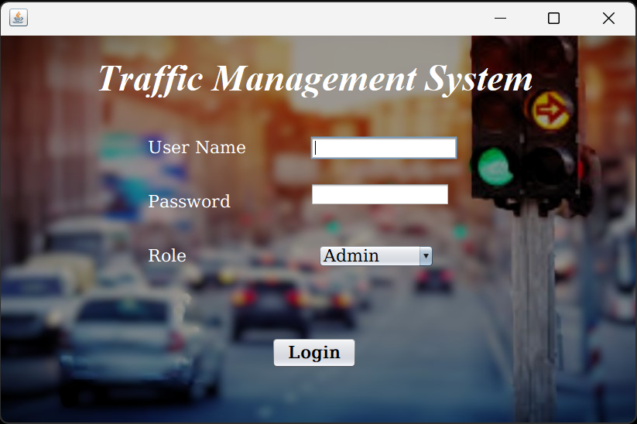

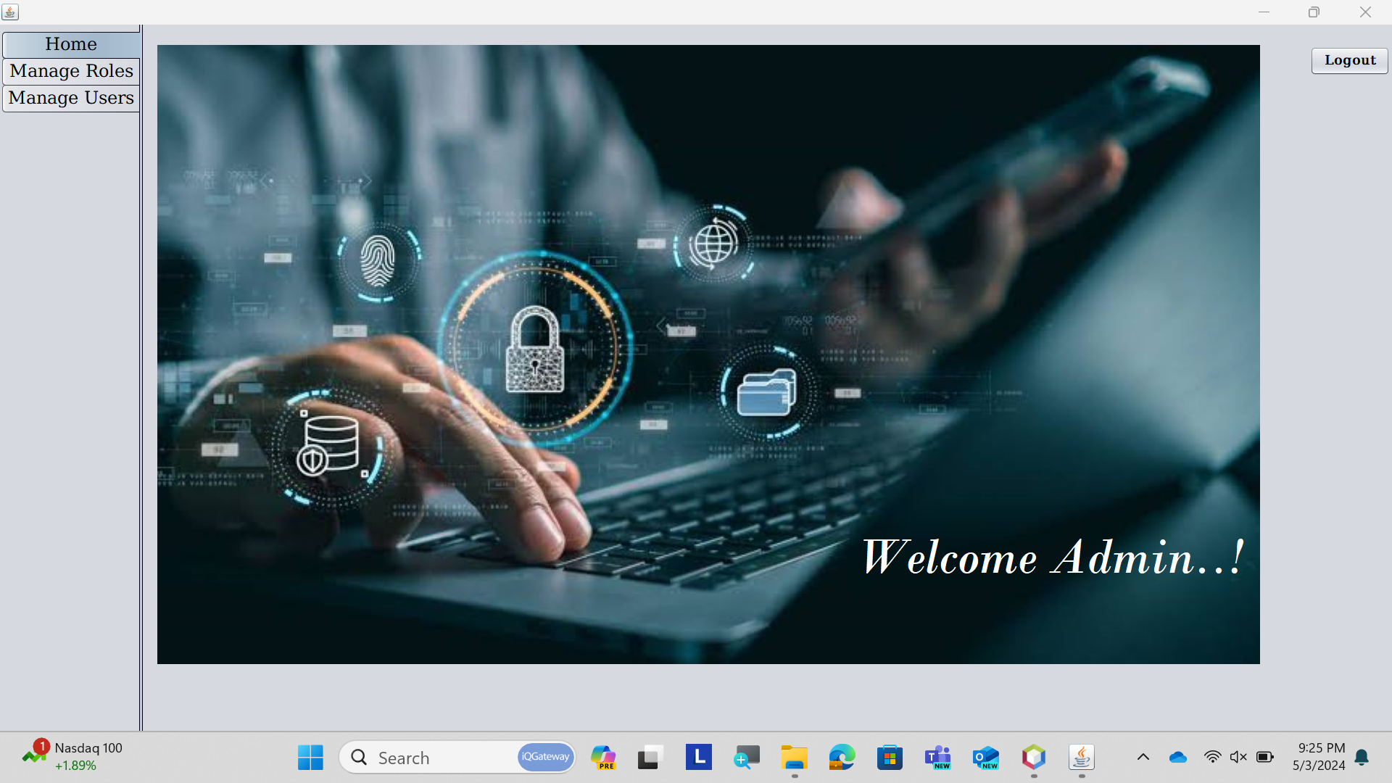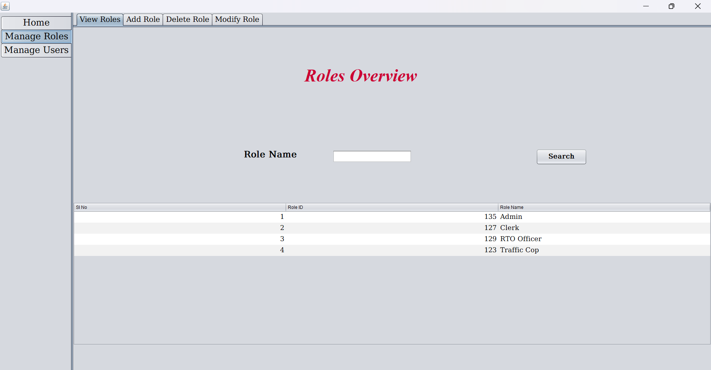

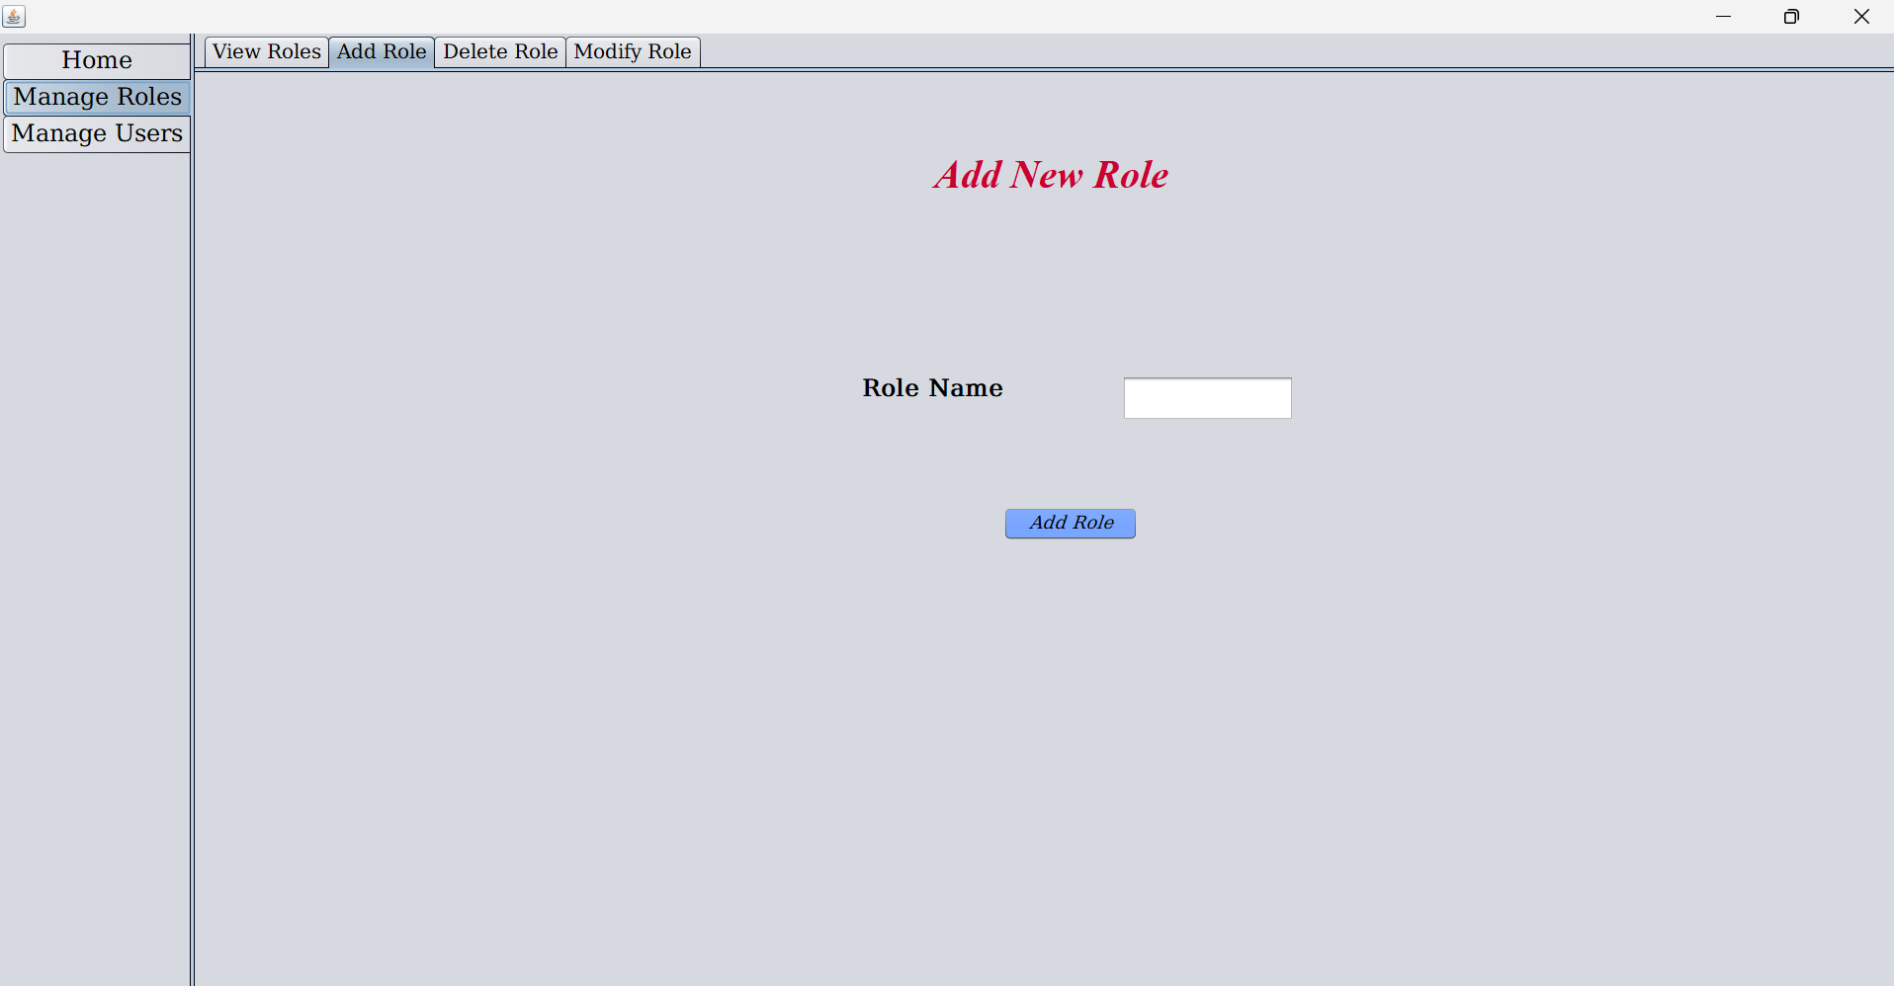

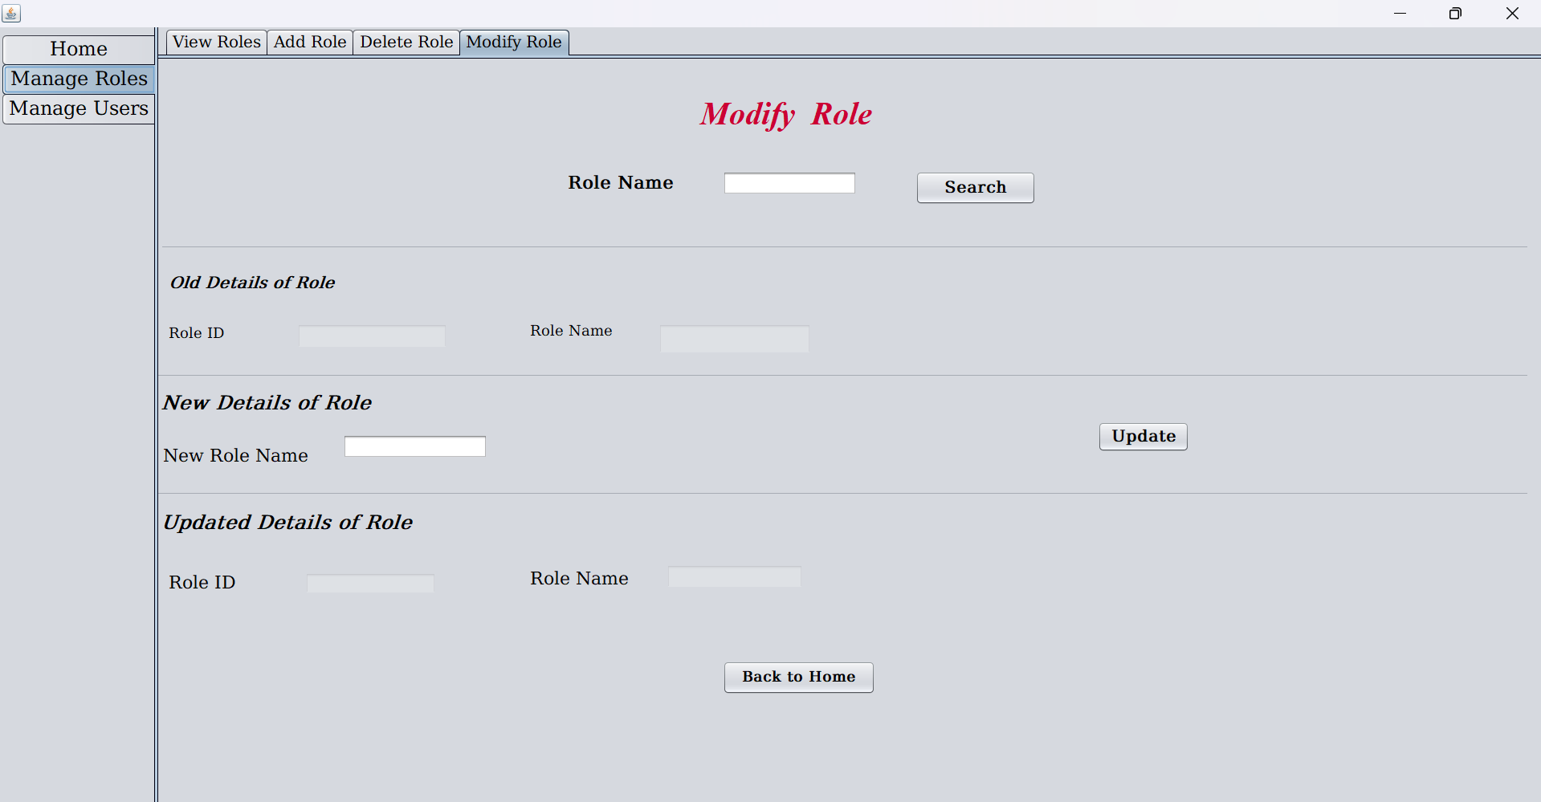

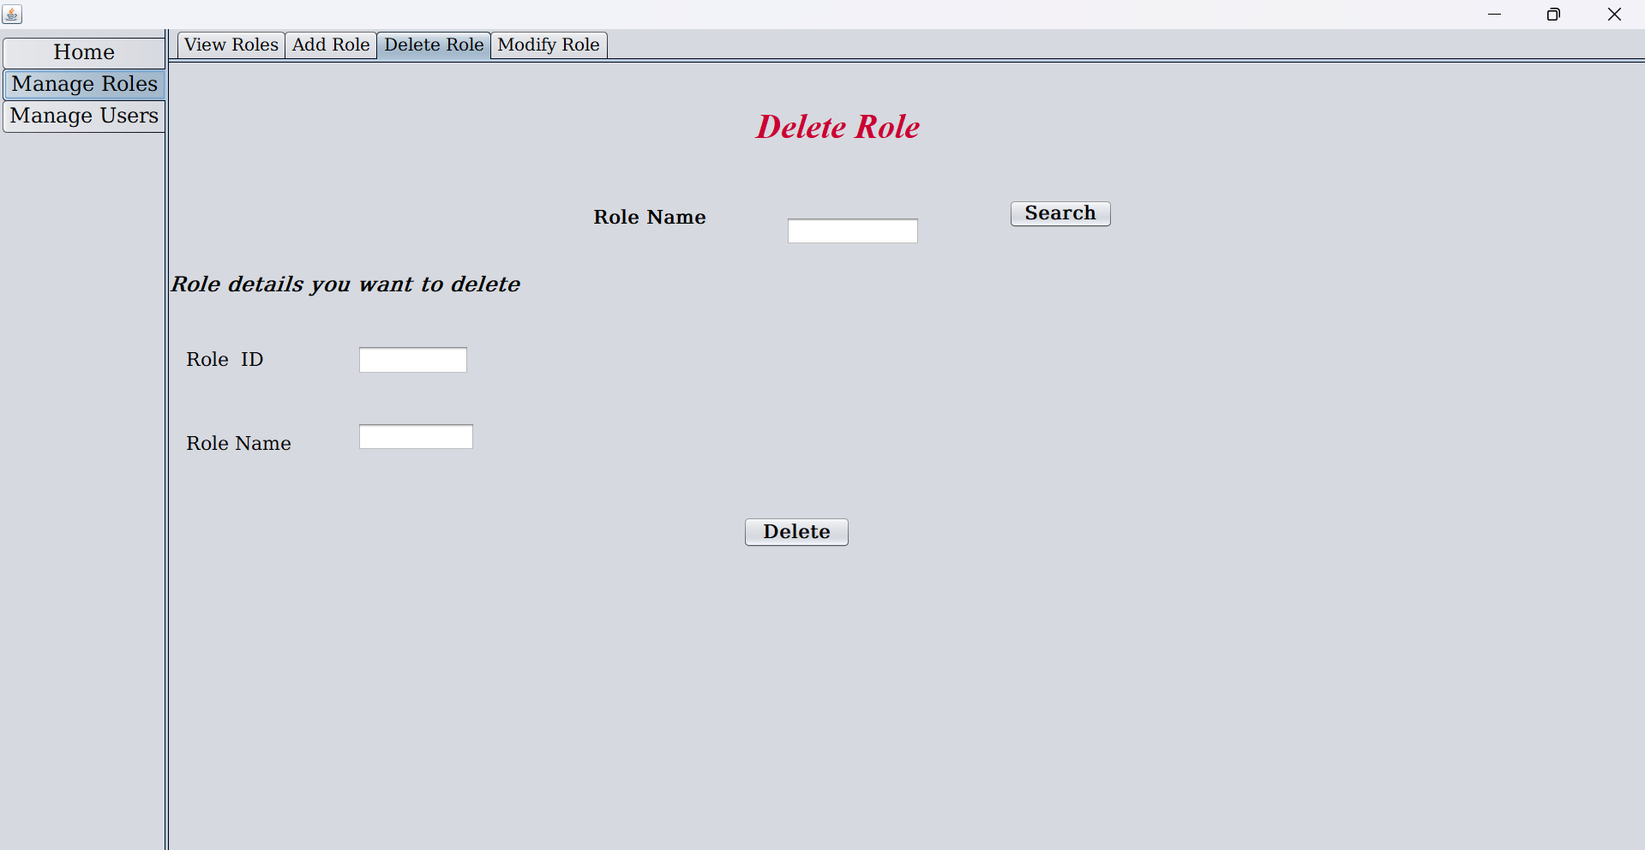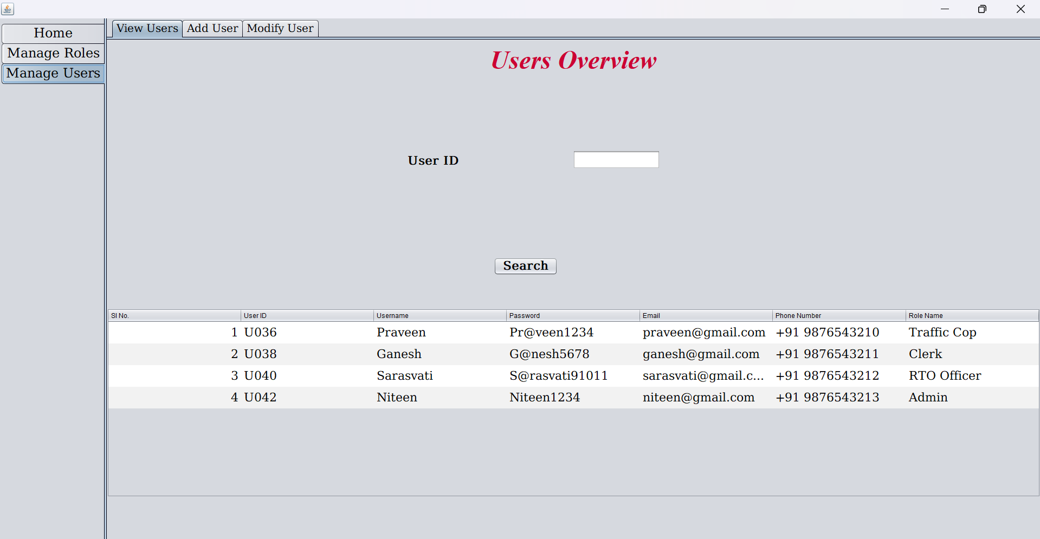

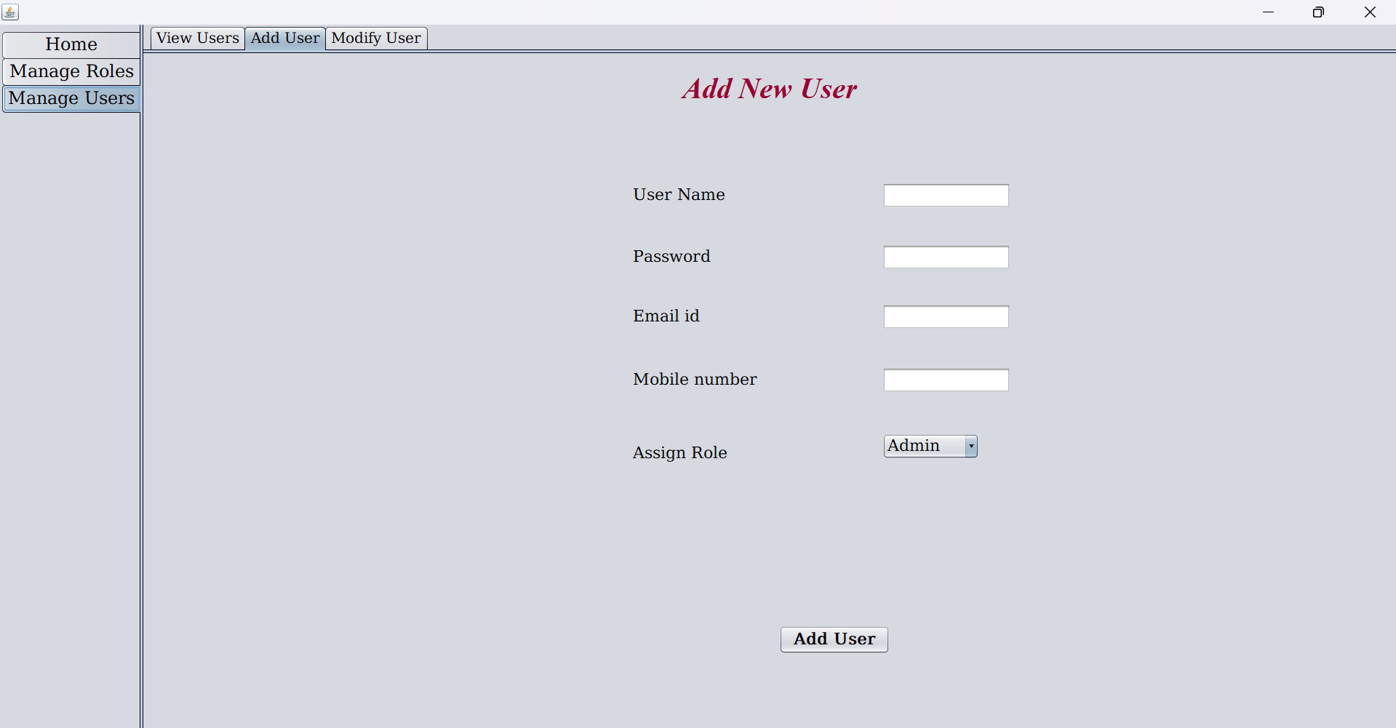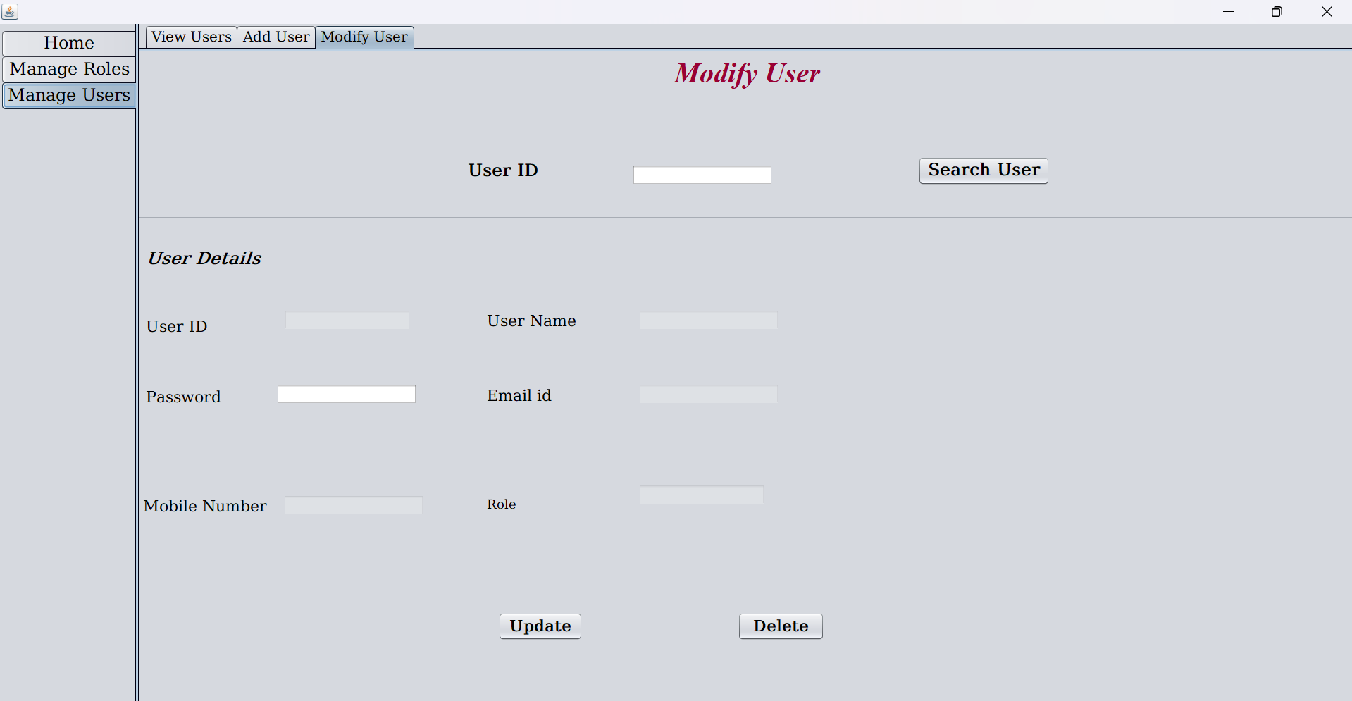

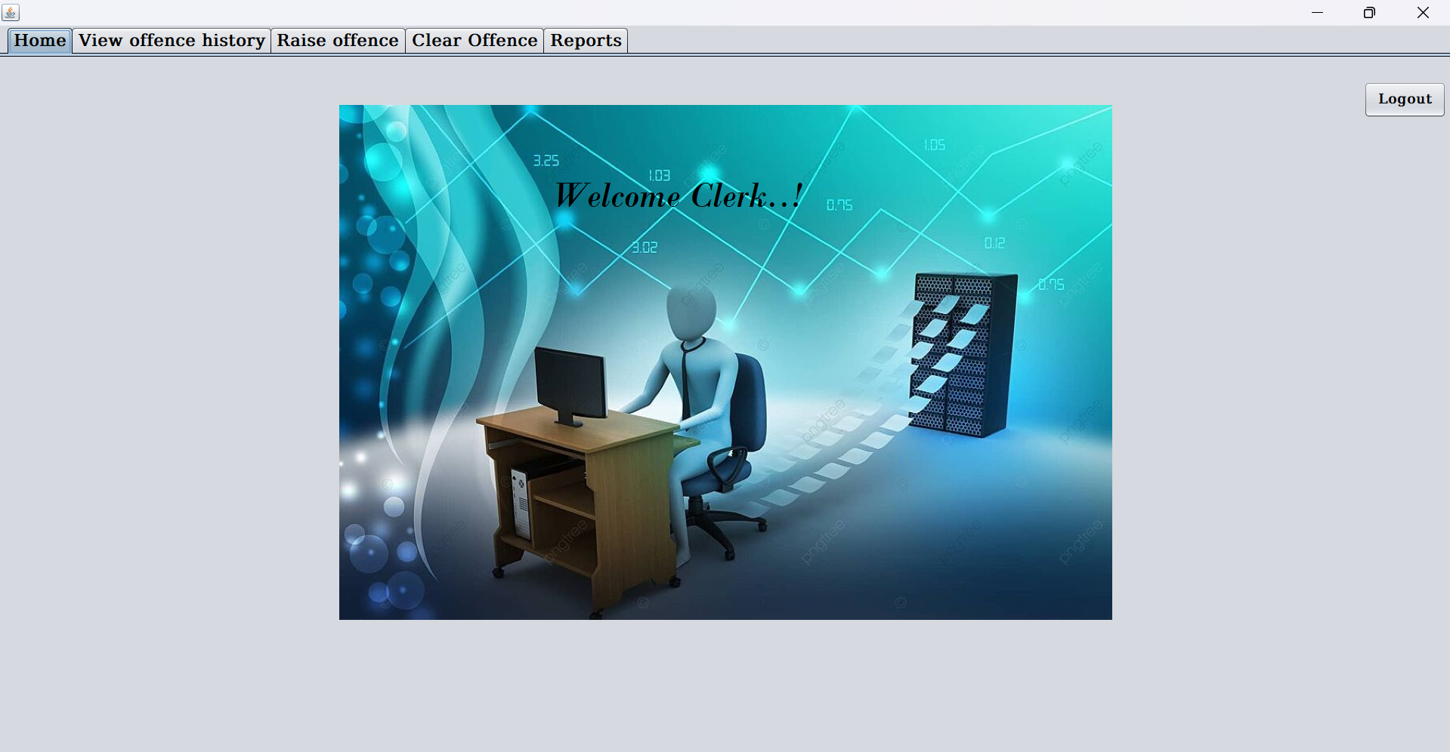

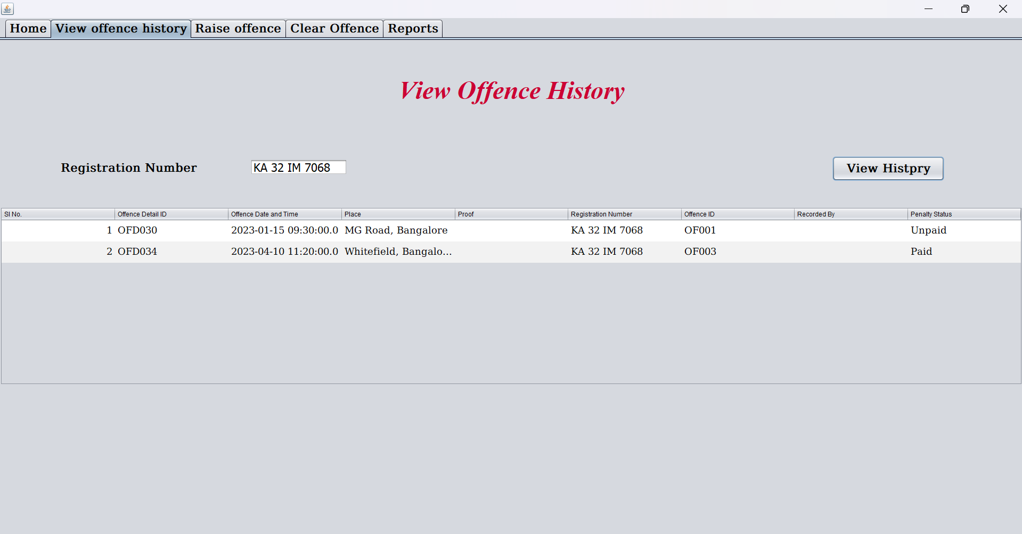

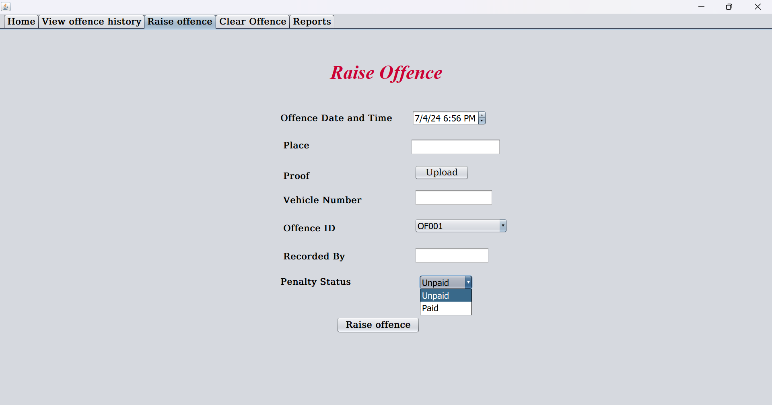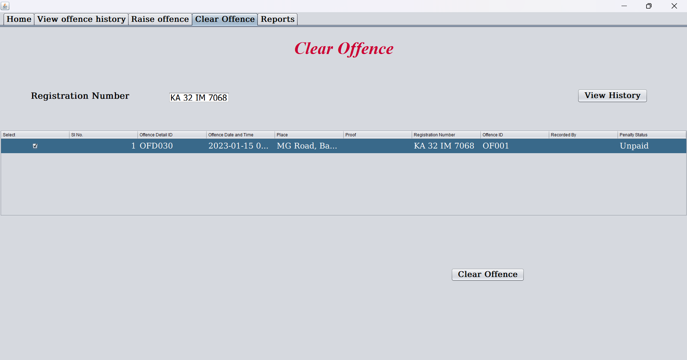  
  
  
  
  
  
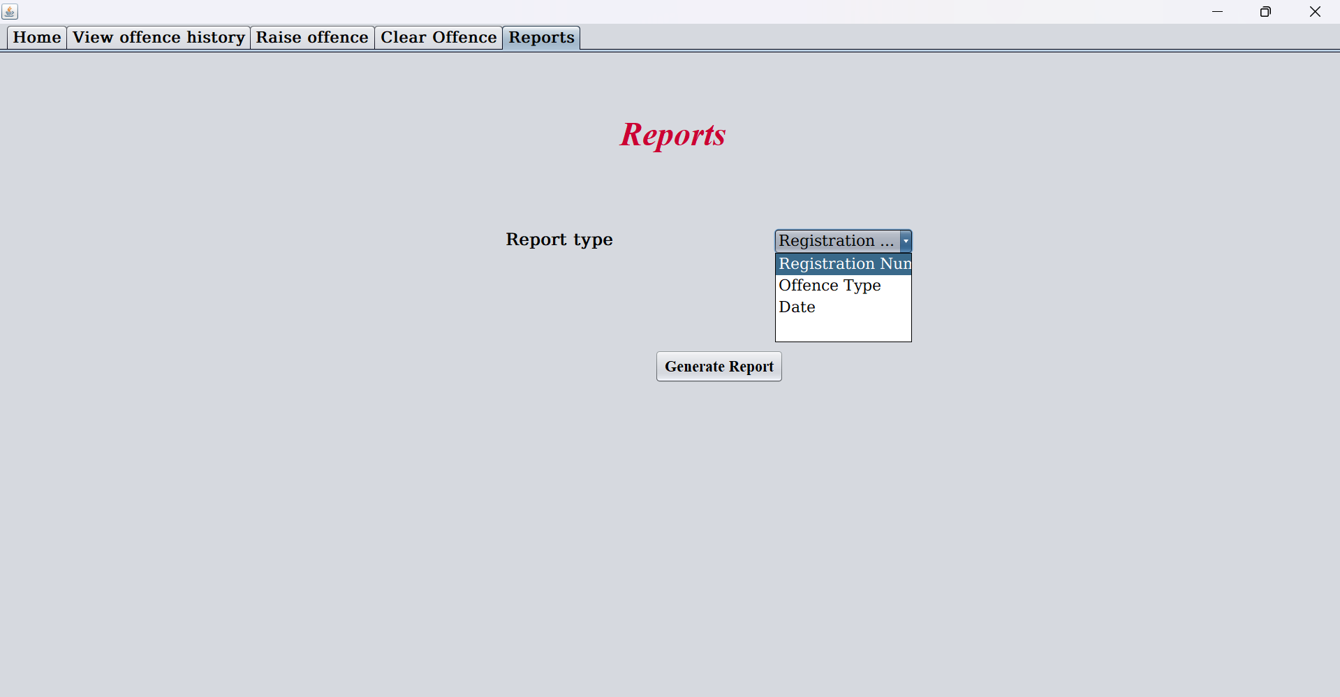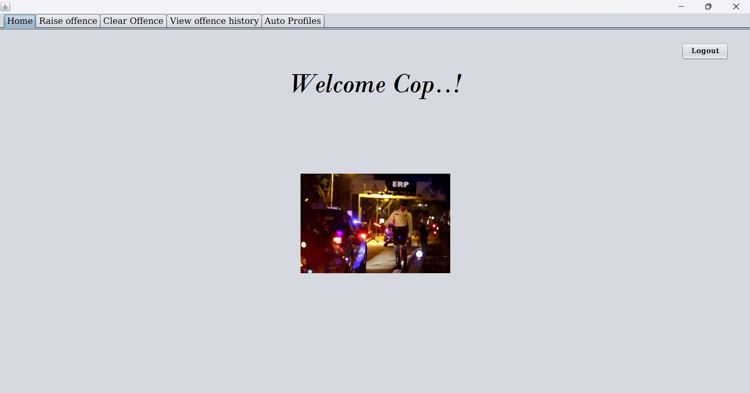

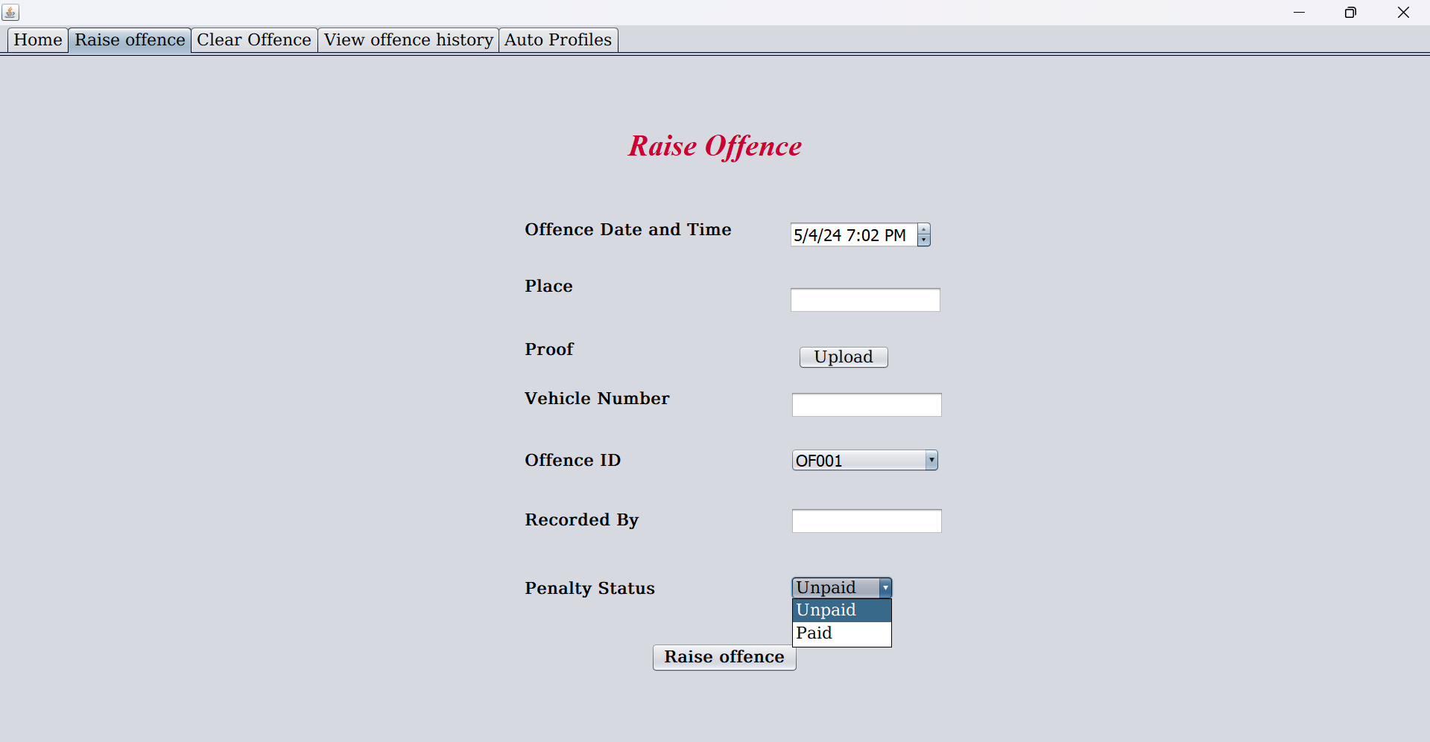

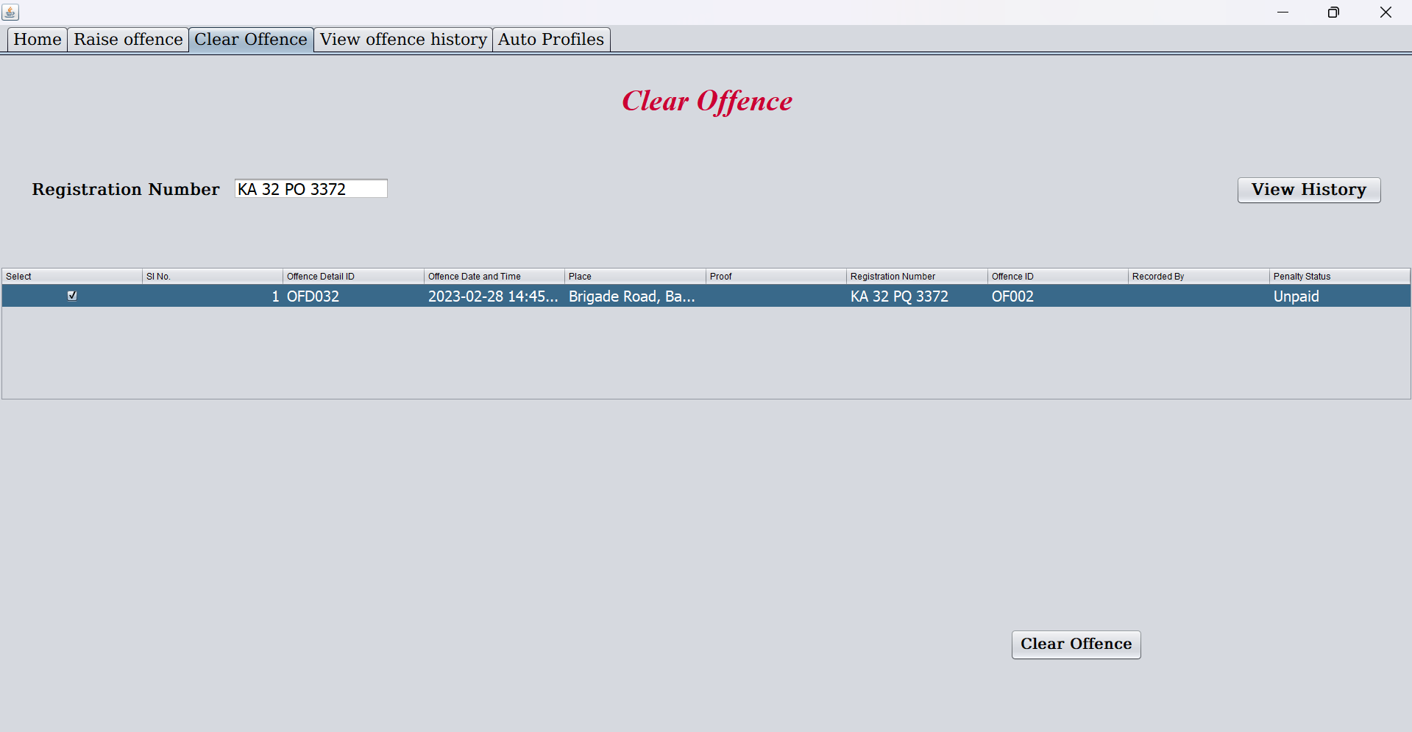

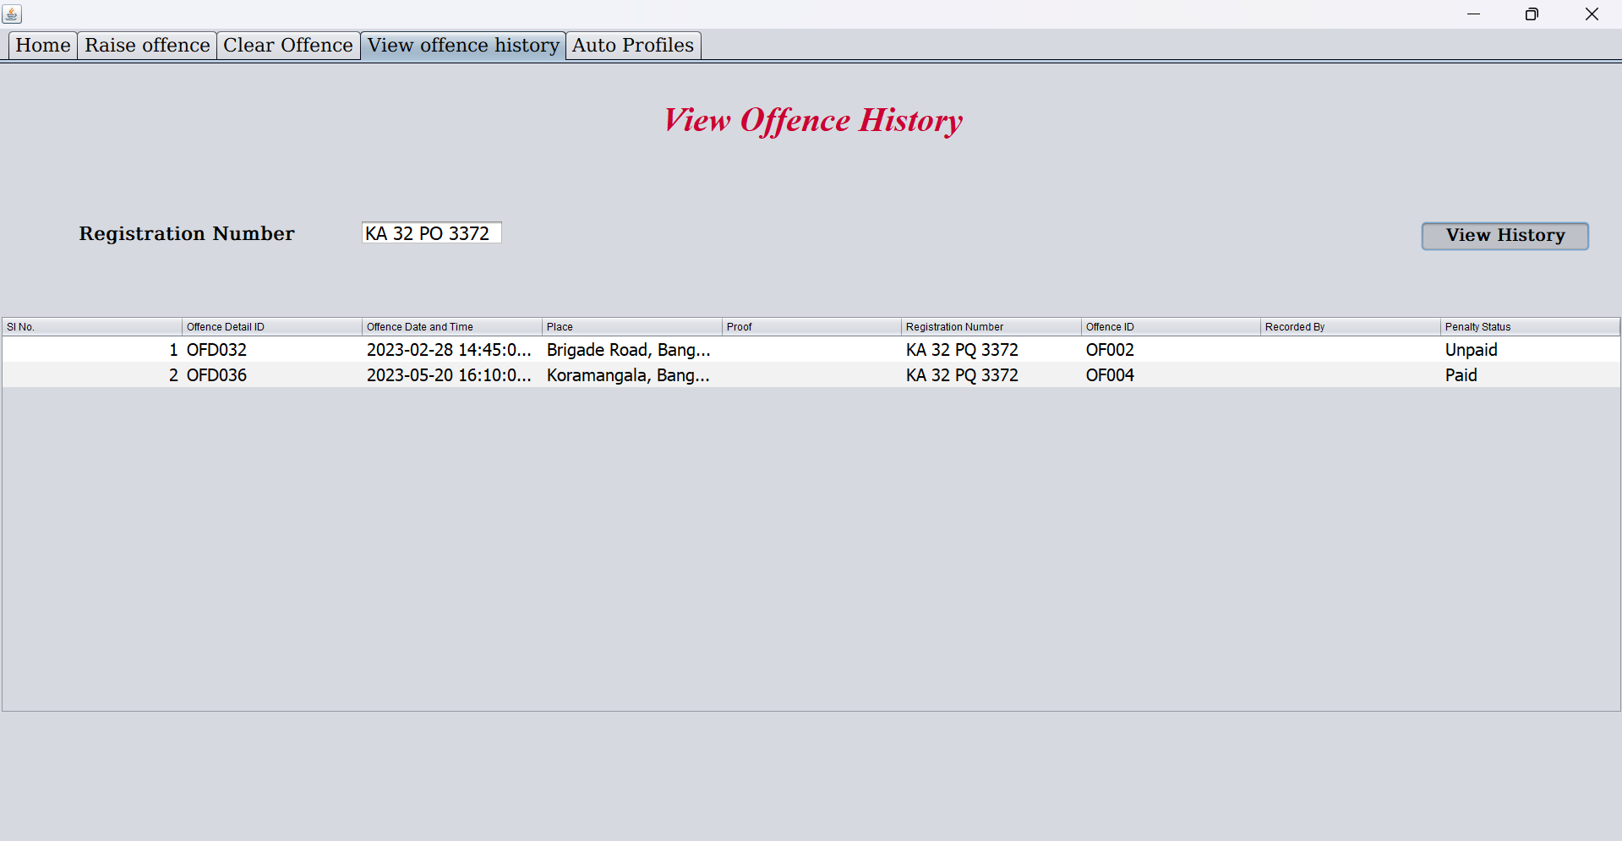

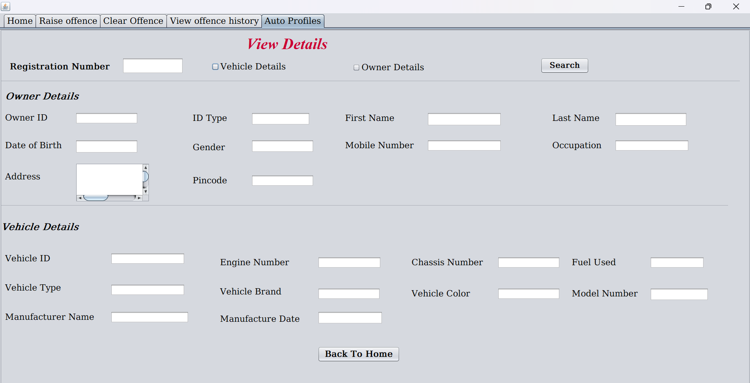

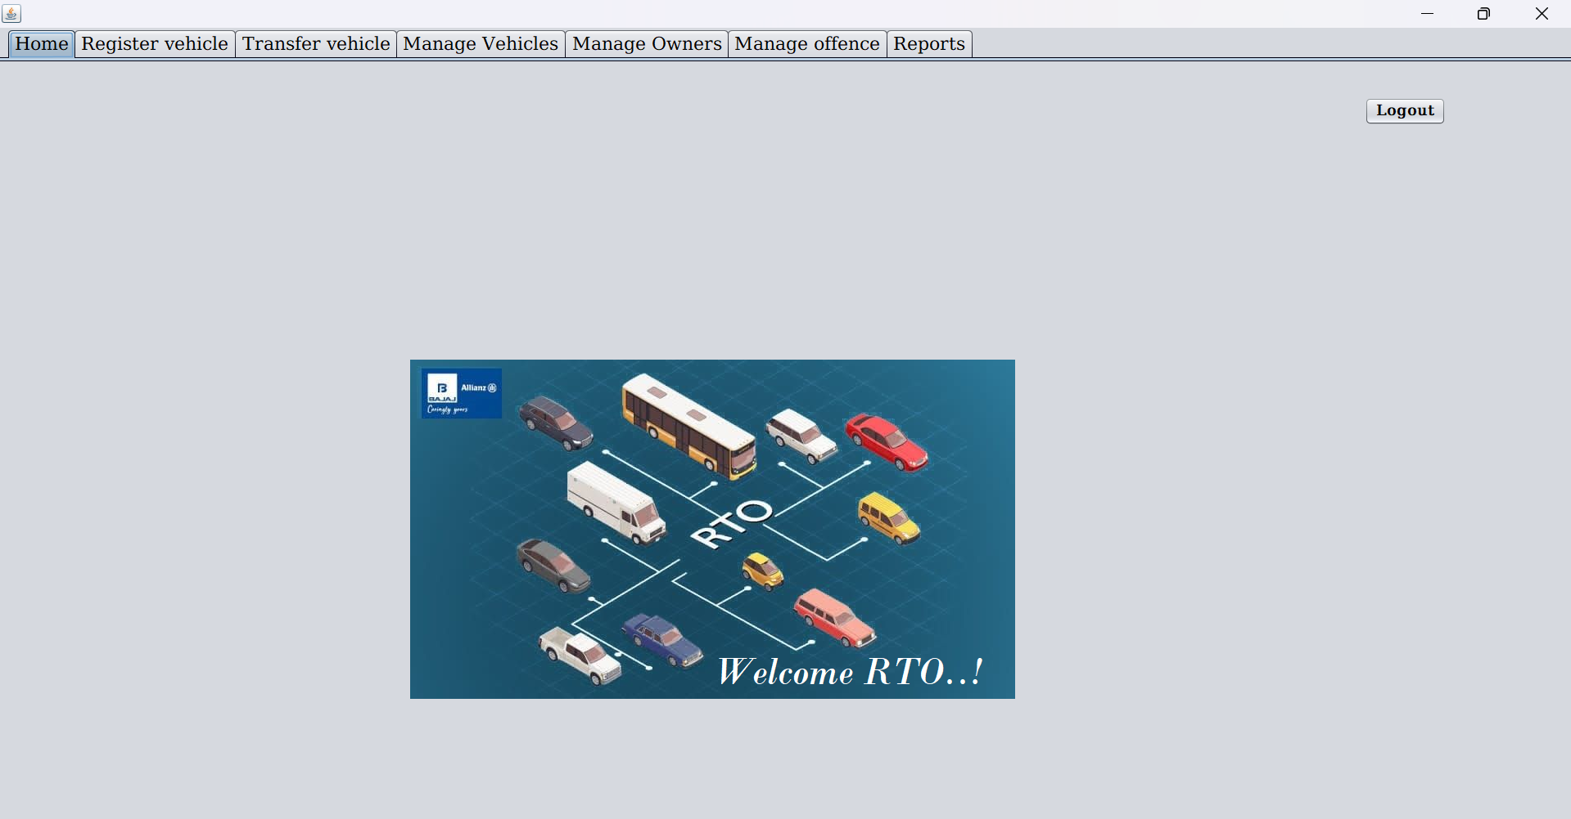

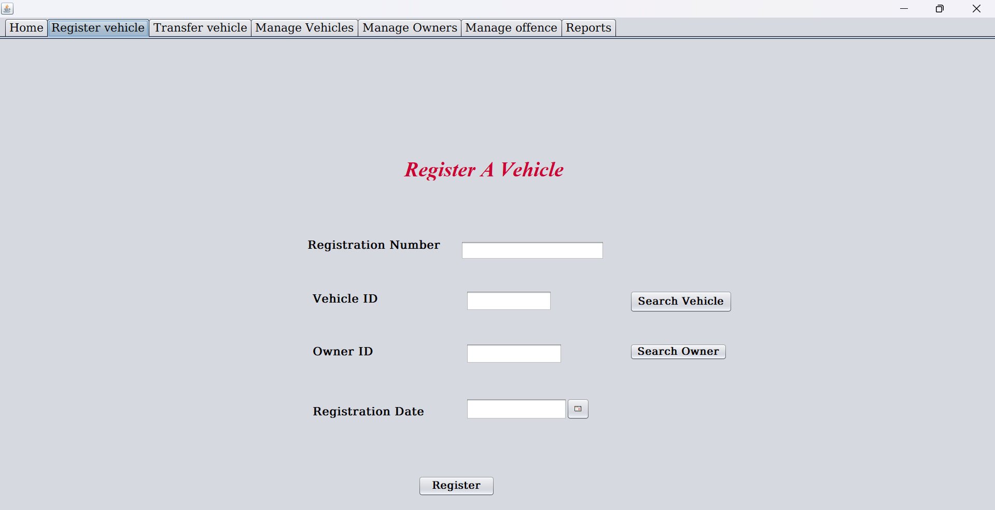

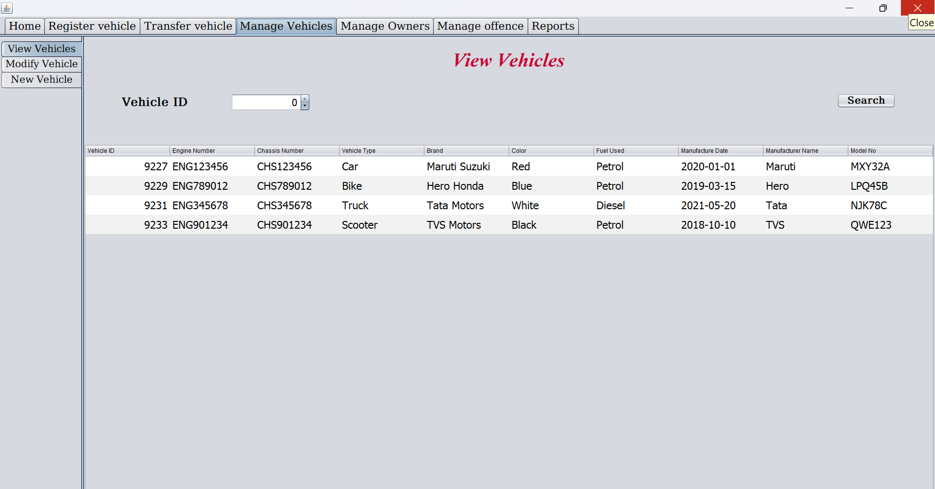

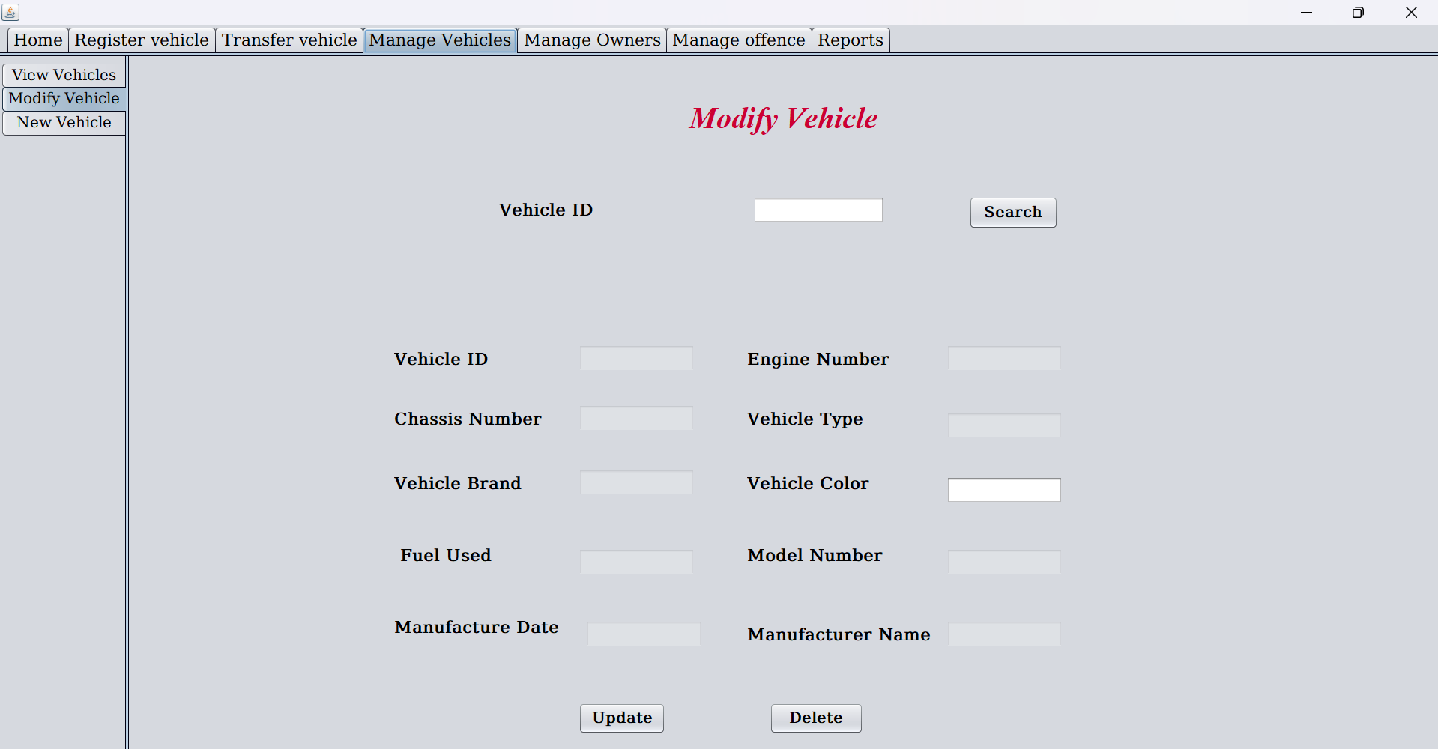

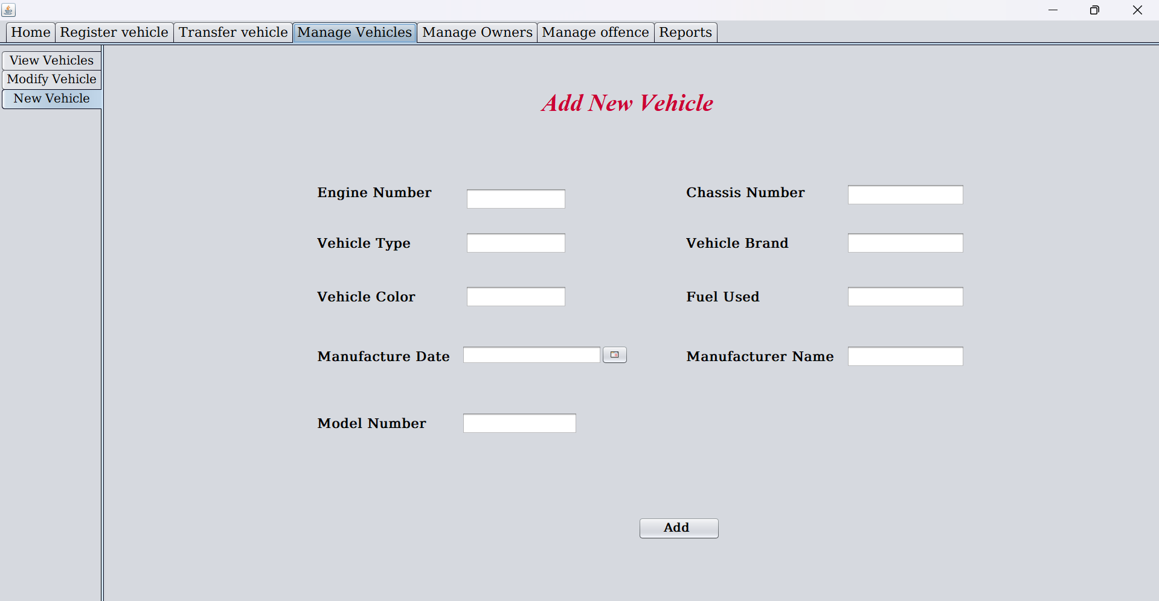

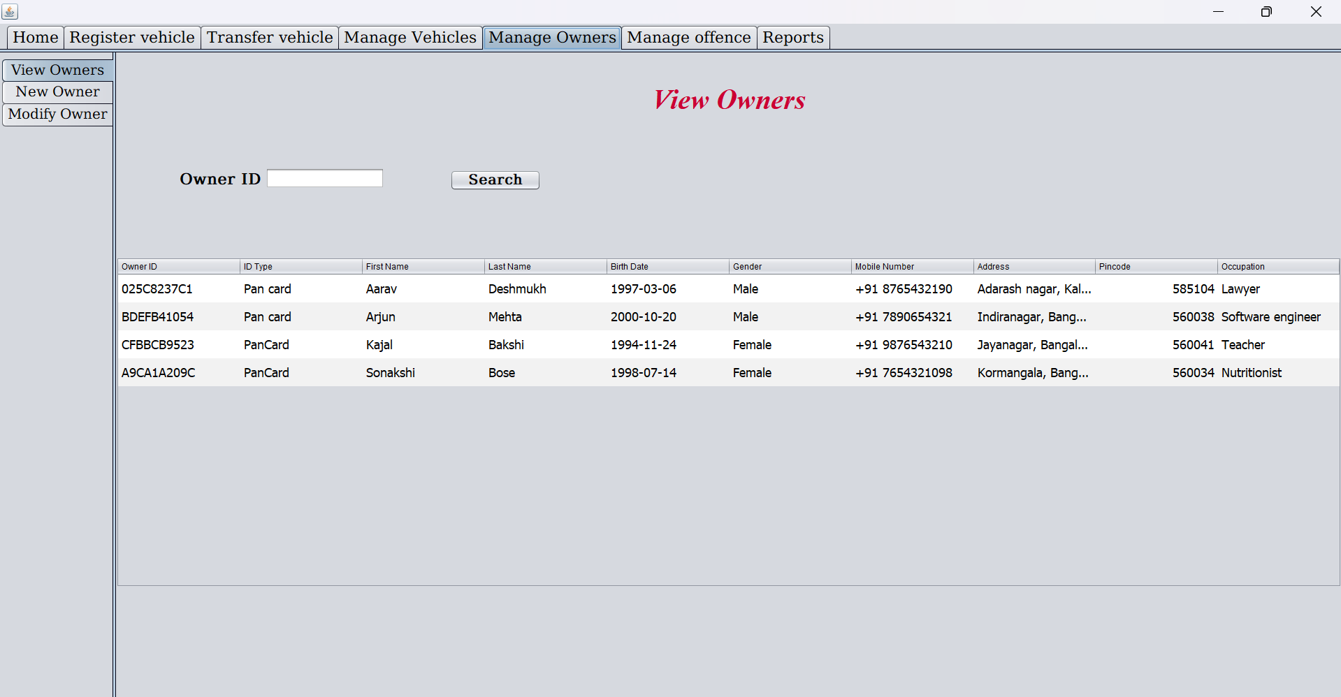

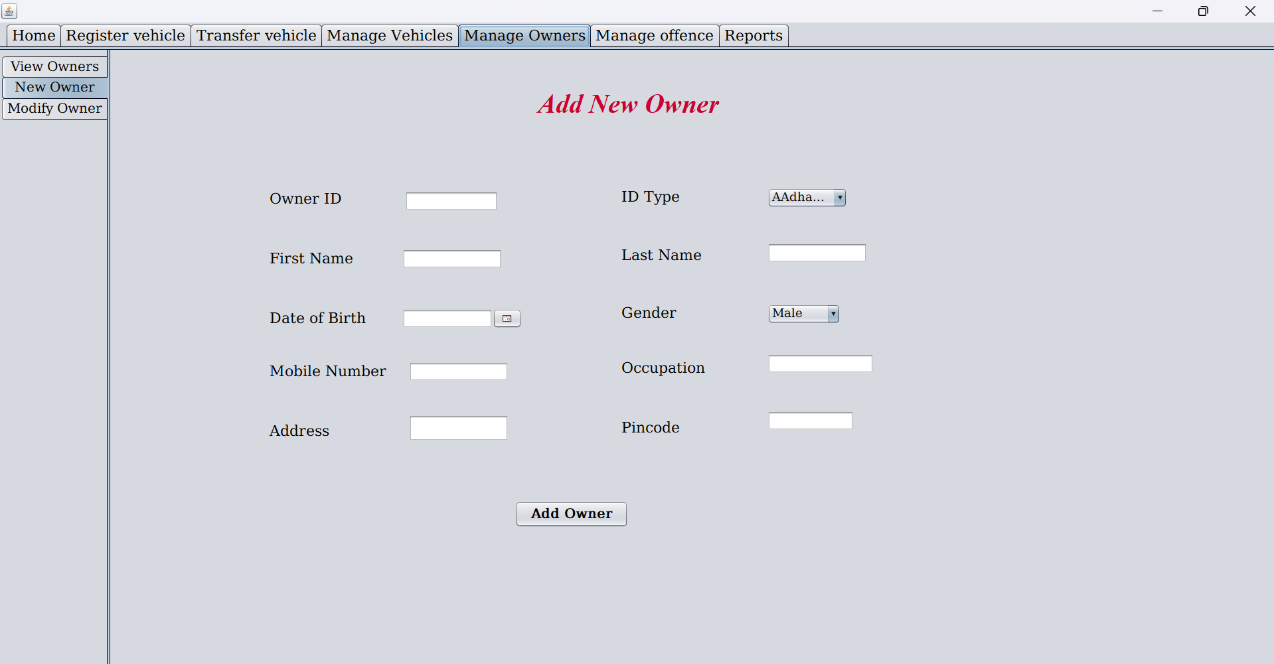

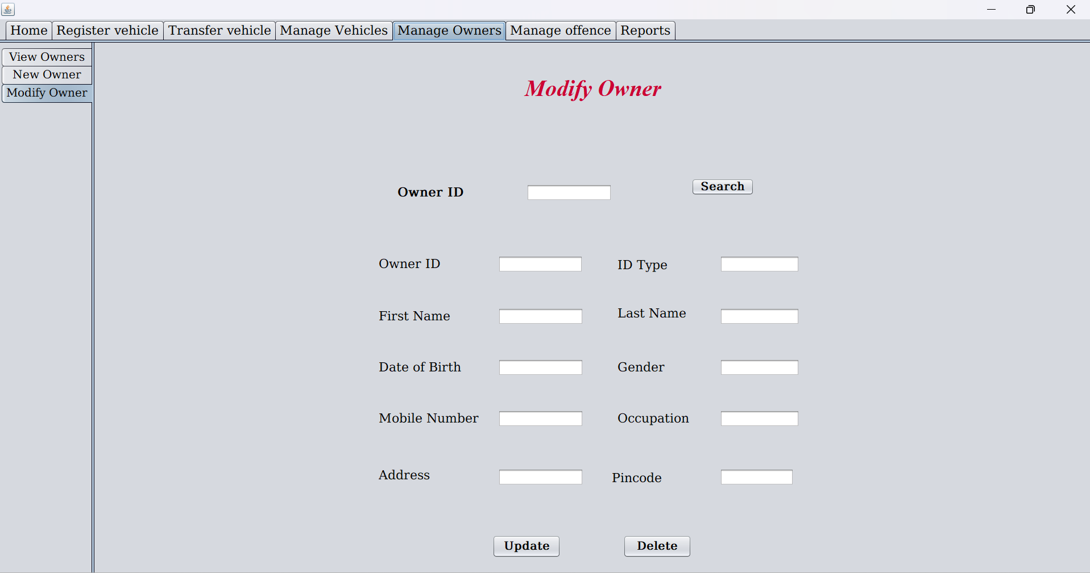

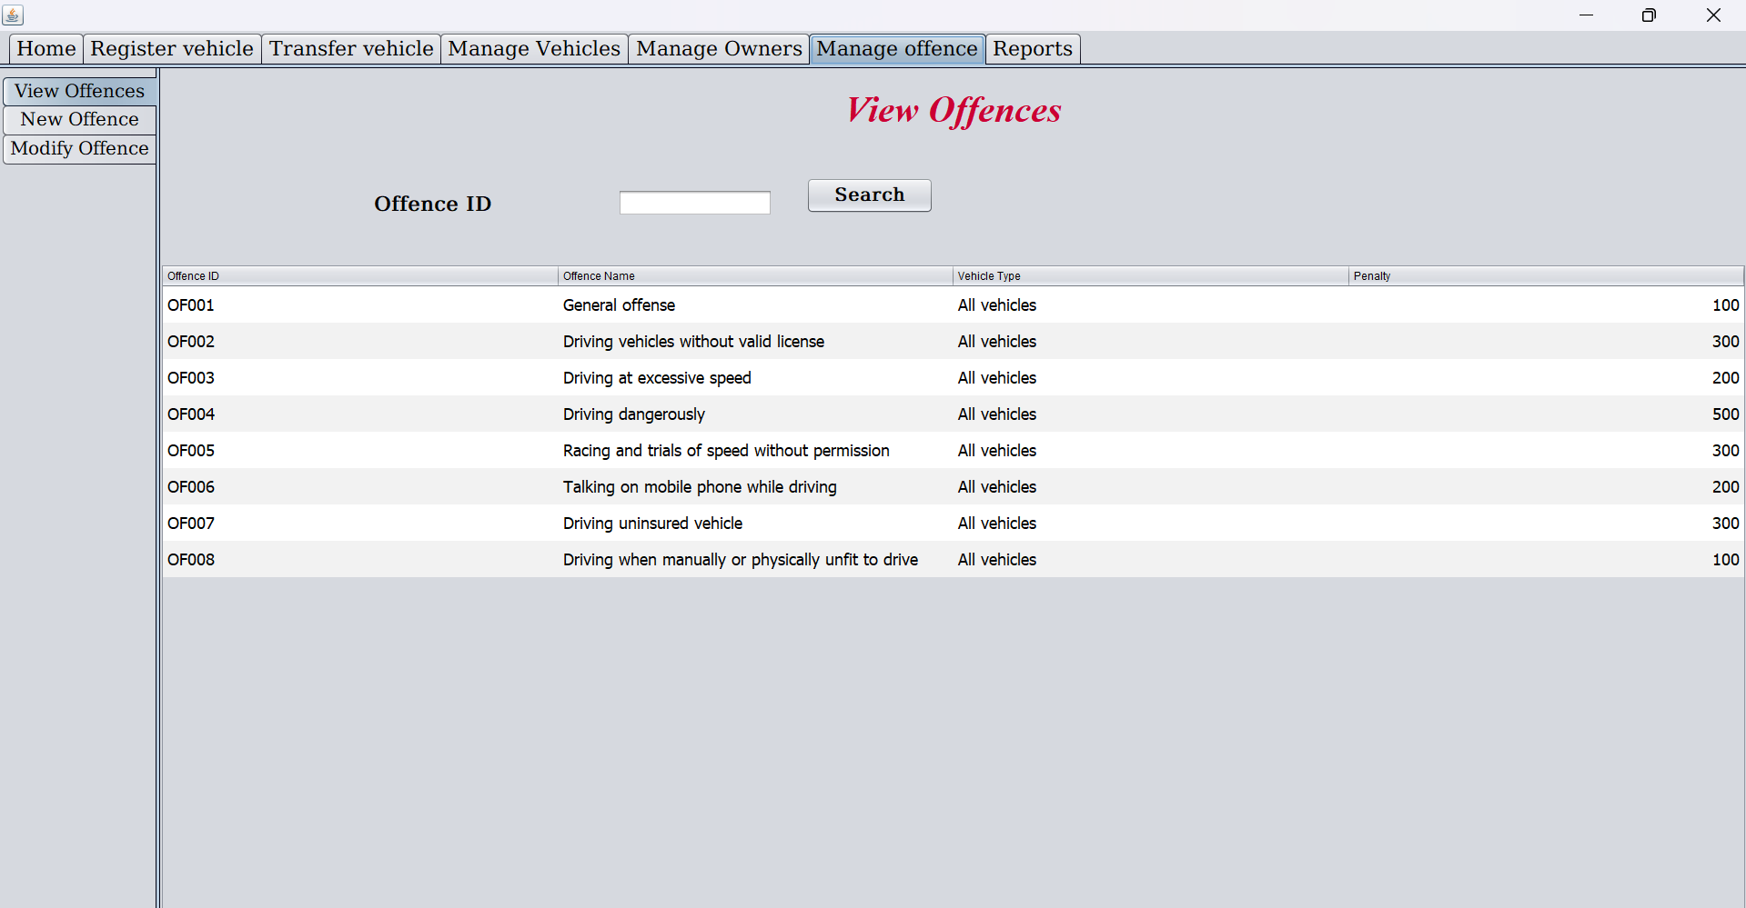

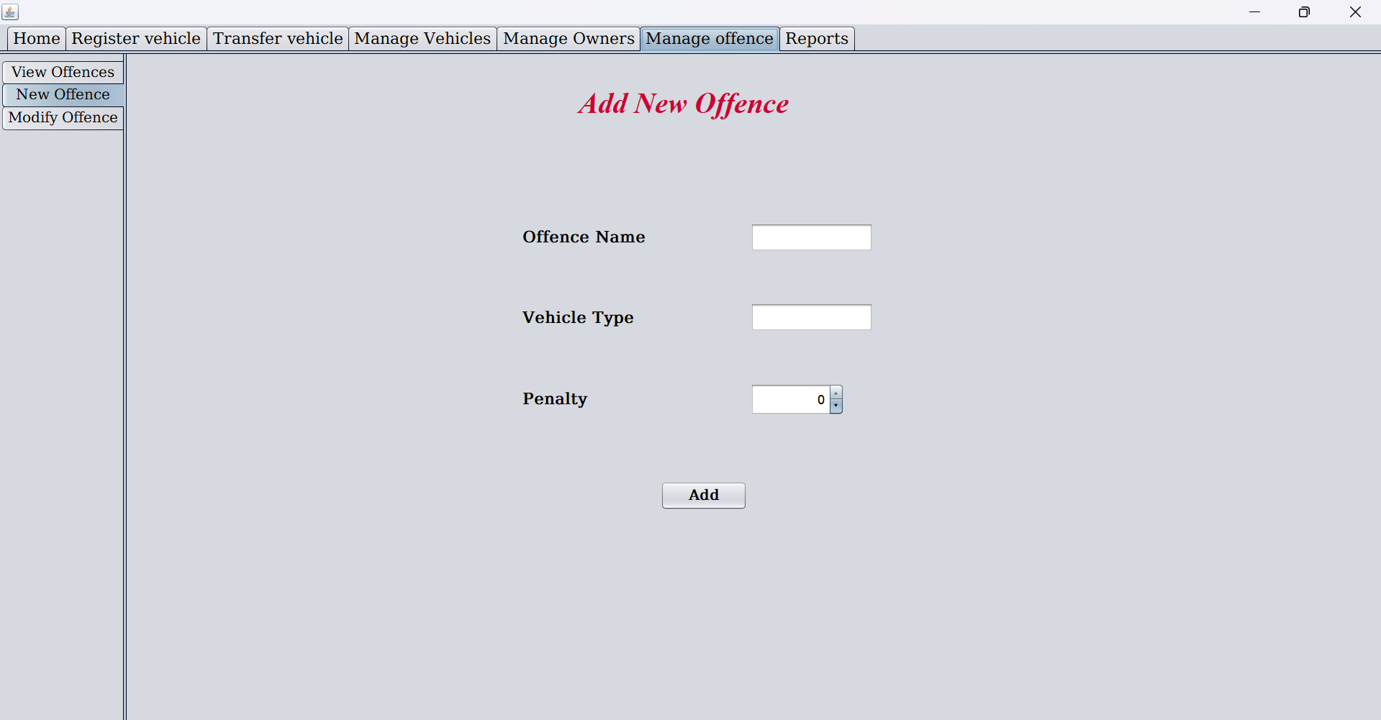

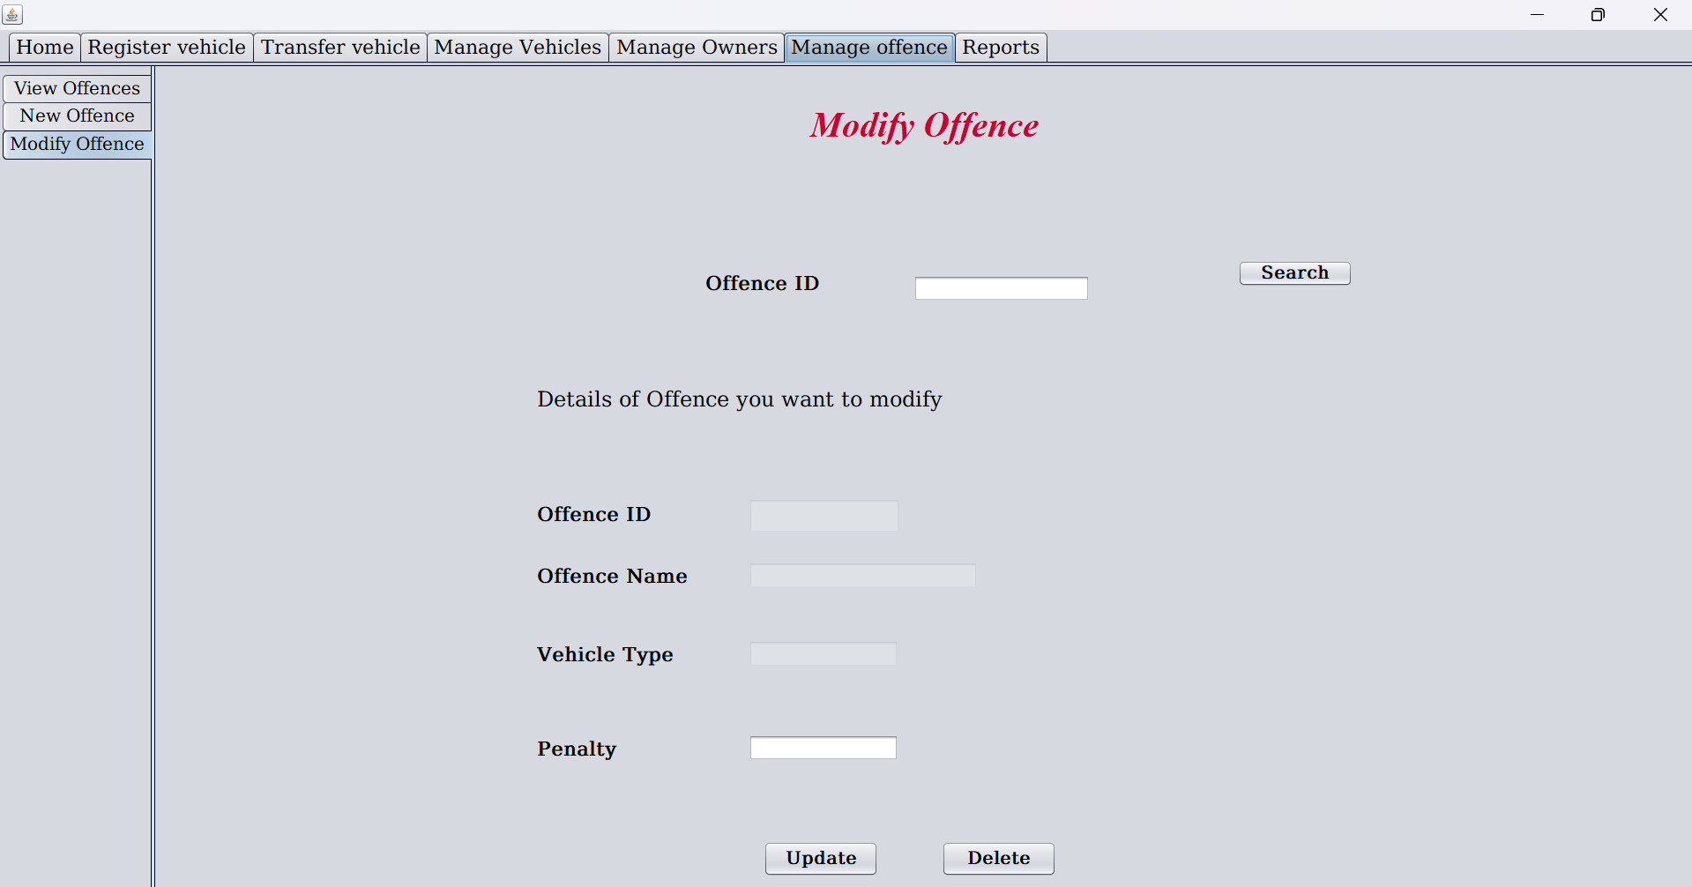

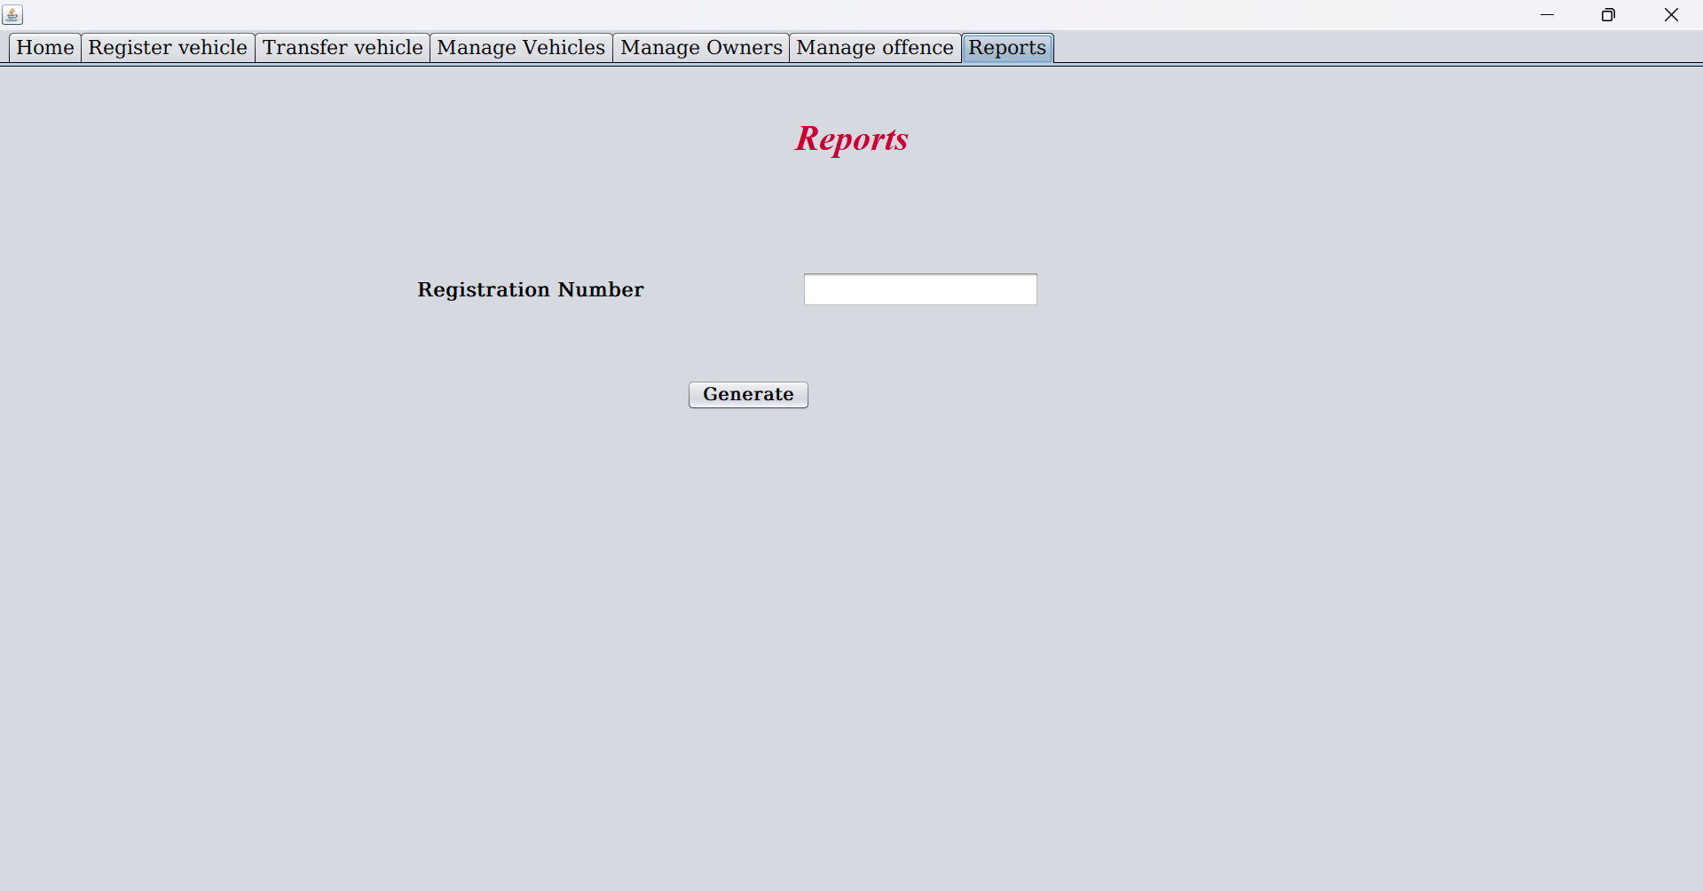

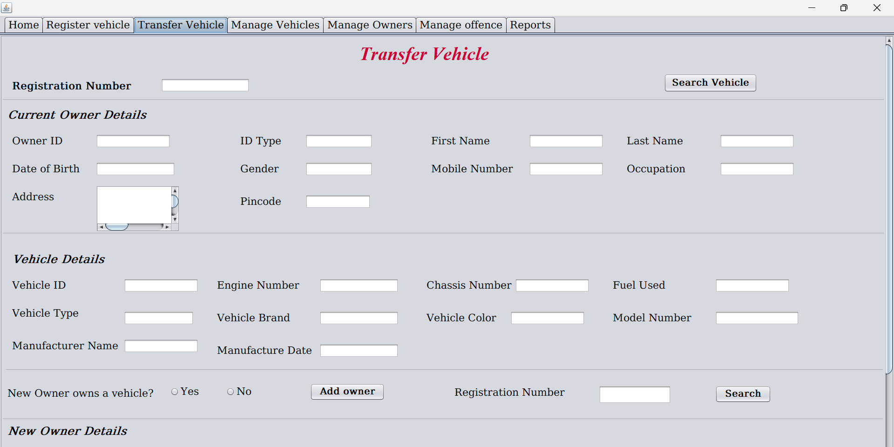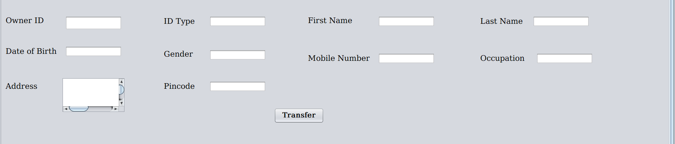

## External Interface Requirements

*NA*

# Project Execution Related Requirements

## Development Environment

## *Technologies to be used for development of the Application:*

* *Java SE*
* *Java Swings/AWT*
* *SQL and PL/SQL*

*Software tools that can be used for development:*

* *Netbeans*
* *Sql Developer*
* *jDeveloper*
* *Enterprise architect*

## Design requirements

###### *Java swings is used for designing this application.*

## Coding requirements *Complete knowledge regarding java SE and oracle 10g XE*

## Error handling requirements

*Exceptions are handled by try-catch block and throws keyword.*

## Resource Requirements *Technologies to be used for development of the Application:*

* *Java SE*
* *Java Swings/AWT*
* *SQL and PL/SQL*

## Risk management

*Not applicable.*

## Training Requirements *Proper training must be provided regarding the usage of the application to end user. Prior using the application users must go through the demo of using TMS application.*

# Testing Requirements *Both unit testing and integration testing must be done so as to ensure the application meets as per the requirements of the customer. Unit testing is done each module separately, where as integration testing is done on all the modules once the module are integrated together.*

# Quality Assurance Activities

NA

# Software Acceptance Criteria *User acceptance test is sole software acceptance criteria. In order to fulfill this criterion, the system should be executed and tested. The error found during this testing must be corrected and latest version of the software must be handed over to the client for acceptance testing.*

# Deliverables

## List of Deliverables

*Not applicable*

## Delivery

*Not Applicable*

# Requirements Acceptance Statement NA